

**RESOURCE ORDER FORM**

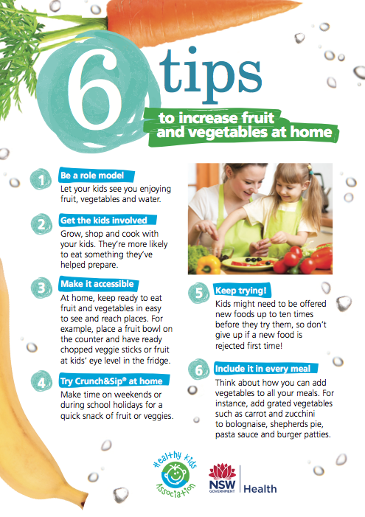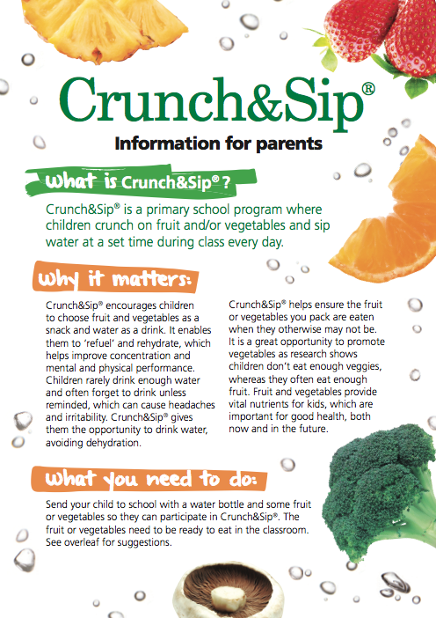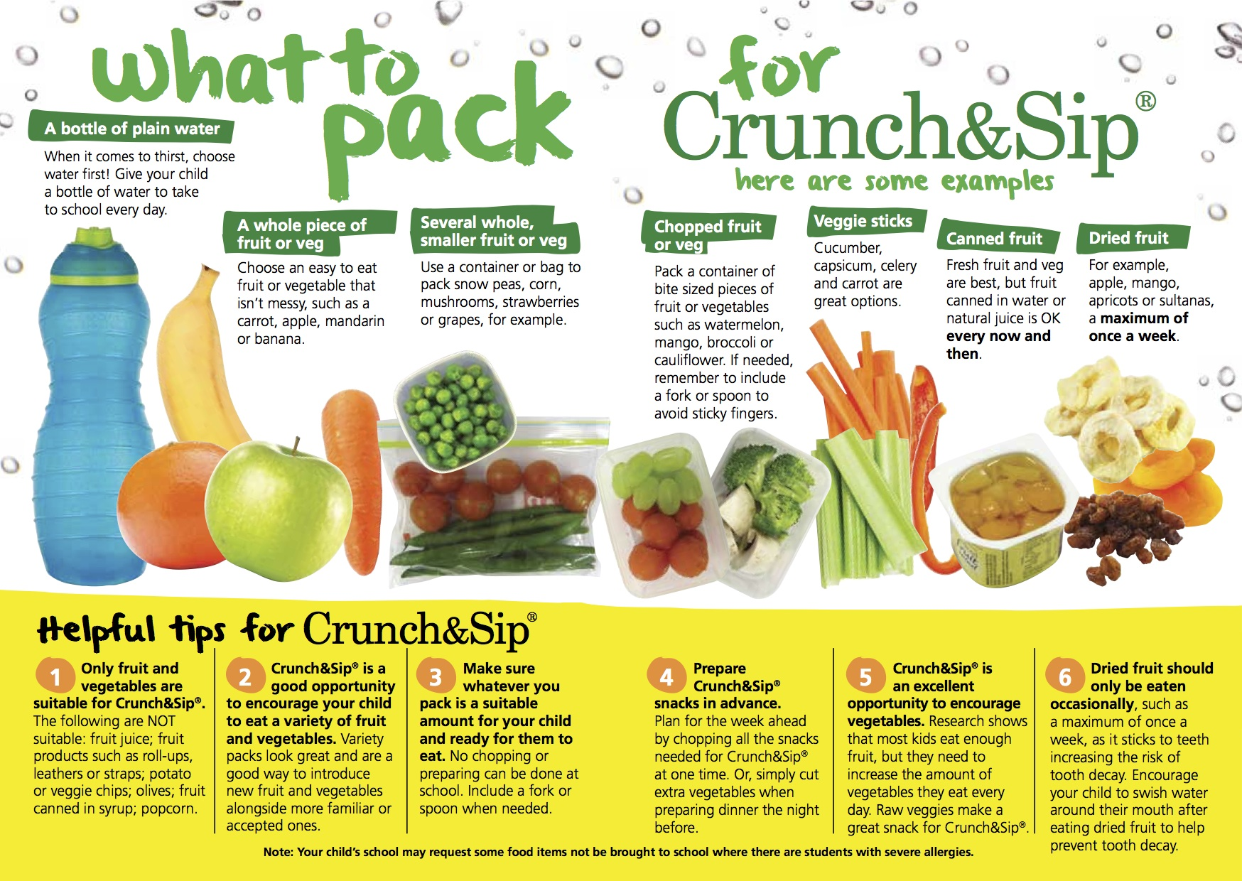**Crunch&Sip® Parent Brochures**

Complete form and email to [**popresources@doh.health.nsw.gov.au**](mailto:popresources@doh.health.nsw.gov.au)or fax form to **1300 550 570**

|  |  |
| --- | --- |
| **School Crunch&Sip Coordinator’s name:** | Click here to enter text. |
| **Position:** | Click here to enter text. |
| **Email address:**  ***(Required to confirm order)*** | Click here to enter text. |
| **Phone Number:**  ***(Required for courier)*** | Click here to enter text. |
| **School name:** | Click here to enter text. |
| **Full school postal address:**  ***(Delivery address cannot be a PO Box)*** | Click here to enter text. |
| **Number of students:** | Click here to enter text. |

|  |  |  |  |
| --- | --- | --- | --- |
| SKU | Resource | Maximum Order | Quantity required |
| CSPAR-ENG | Crunch&Sip Parent Brochure - English | 1 per student | Click here to enter text. |
| CSPAR-CHI | Crunch&Sip Parent Brochure - Chinese | 1 per student | Click here to enter text. |
| CSPAR-ARA | Crunch&Sip Parent Brochure - Arabic | 1 per student | Click here to enter text. |
| CSPAR-MAC | Crunch&Sip Parent Brochure - Macedonian | 1 per student | Click here to enter text. |